**ADDING A DATAFILE TO A TABLESPACE**

1. **Dispalying the diskgroups free and available space**

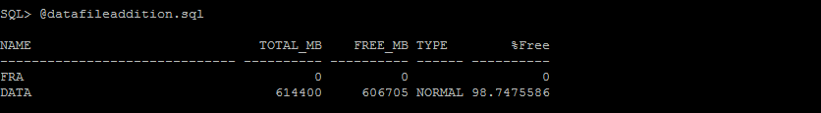

1. **Dispalying the tablespace details**

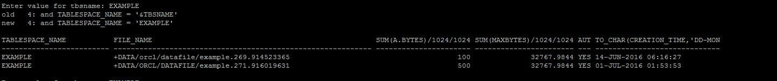

1. **Adding datafile to tablespace**



1. **Displaying the diskgroup free space and newly added datafile to tablespace.**



